**FAST ITERATIVE SOLVERS**

**PROJECT 2: MUTI GRID METHODS**

**Rohan Krishna Balaji – 403596** rohan.balaji@rwth-aachen.de

**Brief Description**

In this project, Multigrid algorithm is implemented to solve the Poisson equation numerically. The main smoothing function is performed by Gauss Seidel iterative algorithm; the purpose of using smoothers is to eliminate high frequency errors.

In the multi grid function, the initially smoothened solution is used to find the residual, then the residual is passed into the coarser level by using the restriction operator, in our problem we consider the lower level to have half of nodes compared to previous level. At this level the error is calculated, further this is passed back into the finer mesh by using prolong operator. But in this project this process happen recursively till the coarsest mesh is solved, at each level the operation is performed twice. Then the difference if error is taken at fine level and applied smoothing again, thus we get the final solution.

Checking the correctness of multigrid solution with n=4 and 7, which produces 16 and 12 (Note in matlab array starts from 1 thus code is modified appropriately) grid points respectively with analytical solution. As particular case just one GS iteration in smoothing solution is shown.

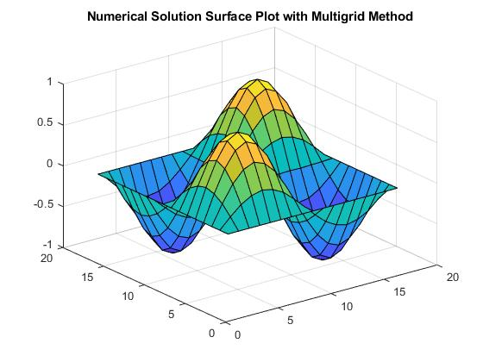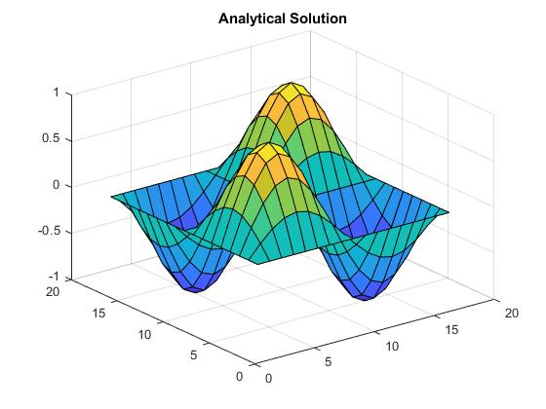

Fig 1,2: Surface plot of Numerical (n=4, nu1=nu2=1) and Analytical solution.

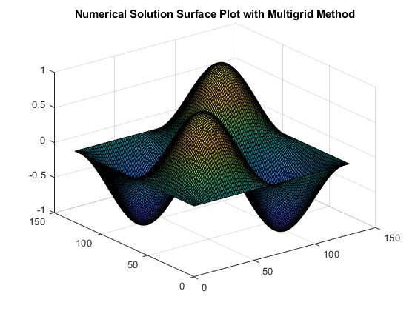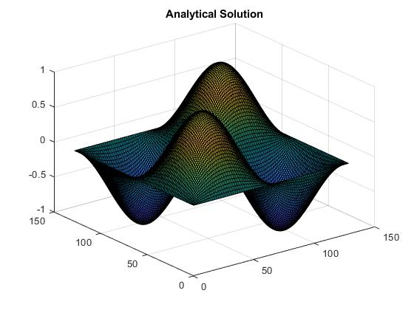

Fig 3,4: Surface plot of Numerical (n=7, nu1=nu2=1) and Analytical solution.

**Convergence Plots:**

To plot the convergence, infinite norm of the residual versus iterations is plotted at every iteration when MG function is called.

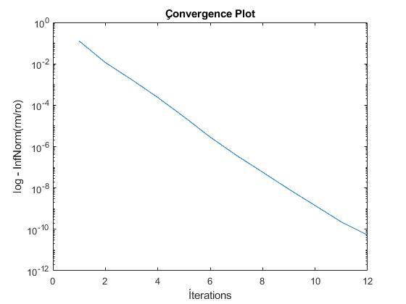

Fig 5: Convergence plot for n=4, nu1=1, nu2=1

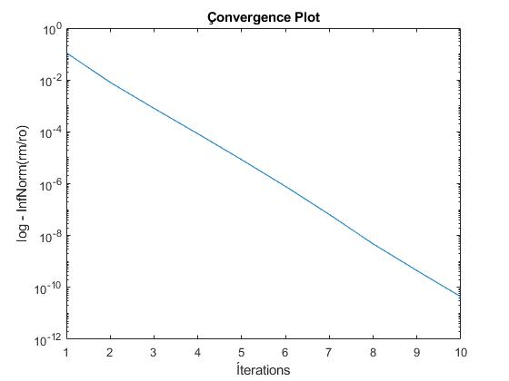

Fig 6: Convergence plot for n=4, nu1=2, nu2=1

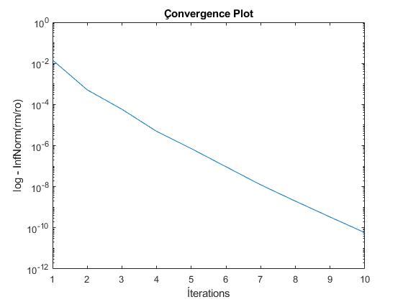

Fig 7: Convergence plot for n=7, nu1=1, nu2=1

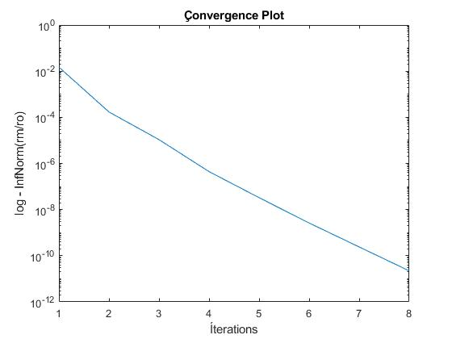

Fig 8: Convergence plot for n=7, nu1=2, nu2=1